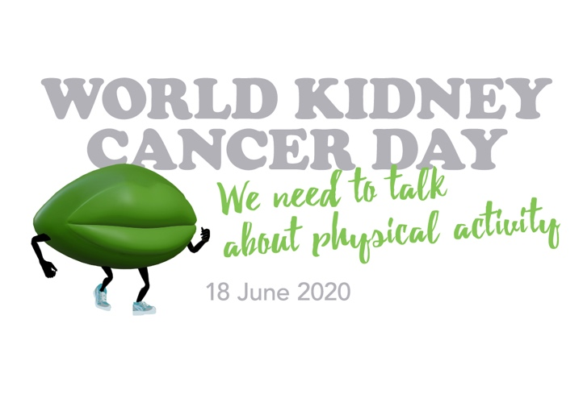
Following is a draft media release that provides key messaging that can be adapted for local market requirements. It is recommended that it is sent out with links to campaign materials in local language and be tailored to the story requirements of specific media channels.

MEDIA RELEASE

World Kidney Cancer Day promotes physical activity for both the prevention and treatment of kidney cancer

Ten years ago, if you were diagnosed with any cancer, you’d probably be told to rest and do as little physical activity as possible. Today, you’re more likely to be told the opposite. Studies now confirm the beneficial role that regular physical activity plays in both the prevention and treatment of many common cancers. Which is why the theme for this year’s World Kidney Cancer Day on 18 June is ‘We need to talk about physical activity’.

“The evidence supporting the benefits of physical activity is growing every day,” commented International Kidney Cancer Coalition (IKCC) Chair, Dr Rachel Giles. “But currently three out of four kidney cancer patients worldwide aren’t doing even the recommended minimum, with half doing no physical activity at all”.

The face of this year’s World Kidney Cancer Day campaign is Dr Linda Trinh, a world leader on physical activity and cancer, from the University of Toronto in Canada. Across a series of campaign videos, Dr Trinh talks about how physical activity can make a huge difference to both kidney cancer prevention and improving the treatment outcomes and quality of life for those who have it. Kidney Cancer’s ‘We need to talk’ green lips mascot also features in the campaign, modelling various activities from walking to swimming.

Studies show even moderate physical activity can reduce your risk of getting kidney cancer by up to 22% and improve treatment outcomes by up to 15% if you have been diagnosed. The benefits aren’t just physical. It can also reduce cancer-related anxiety and depression and improve general wellbeing and quality of life. Given a recent IKCC study showed that 96% of kidney cancer patients worldwide experience psychological problems, 30 minutes exercise 3 times a week can be life changing.

The global campaign features both long and short form video content on YouTube plus extensive social media and collateral material. You can also download a comprehensive physical activity guide created by Dr Trinh and her colleagues (Attach or provide links to campaign elements in local language).

With many countries still in partial or full lockdown, the campaign includes links to exercise programs you can do in home and reminders to practice social distancing and observe local regulations if organising a group activity.

Here in <County>, local <patient support group> is planning to <local activity>.

For more information on World Kidney Cancer Day 2020 and details of local activity, please contact <local affiliate/organisation representative>.

